

SEO Libraries App (BLUEcloud Mobile 2020.w34)

SirsiDynix

Click & Collect

Click & Collect is a safe and convenient way for patrons to pick up “on-hold” items from select libraries. Patrons can wait in their vehicle while a member of the staff brings the items out to them or they can grab their items from a designated space.

Did you know?



* From the BLUEcloud Mobile application, find an item you would like to place on hold
* Verify that the item is labeled “BEING_HELD” under your list of current holds in **My Account**
* Click **> Click & Collect**
* Enter your information to help the staff identify you when it’s time to bring out your items
* Examples are your vehicle make, model and license plate number
* Select **I’m on my way** when you are headed to pickup your items

1

2

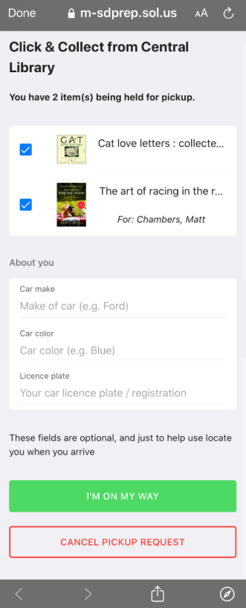

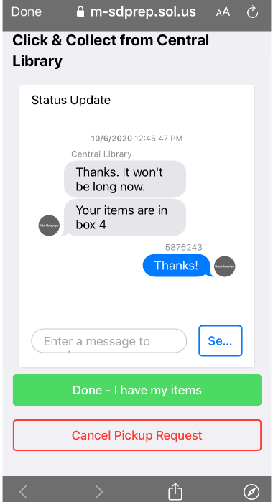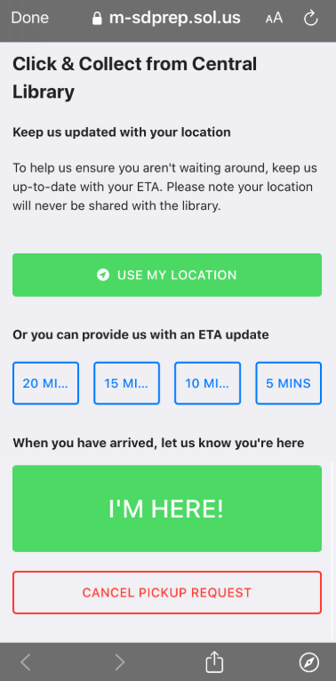

* Allow for either GPS tracking or select an ETA option
* Tap > **I’m here!** when you have arrived
* Receive status updates as the staff prepares and brings out your items
* When you have received your items, hit **Done** to complete the transaction

4

3