

SEO Service Center in partnership with SirsiDynix

SEO Libraries App

Patron Self-Service: Checkout

Using item barcodes, the SEO Libraries App is putting power into patrons’ hands by allowing them to check items out themselves, all from within the SEO Libraries application. This new functionality gives patrons a choice in how they interact with your staff. Please note that the patron will ONLY see the Self-Service: Check-out button if they are within proximity of your library. Location-services must be enabled on the patron’s smartphone in order for this feature to work correctly.

Did you know?

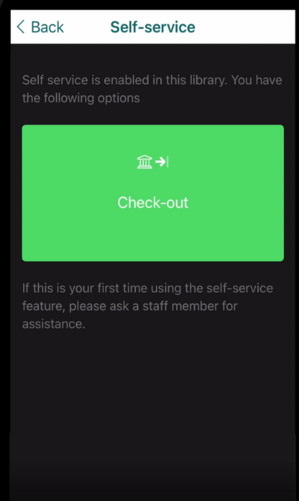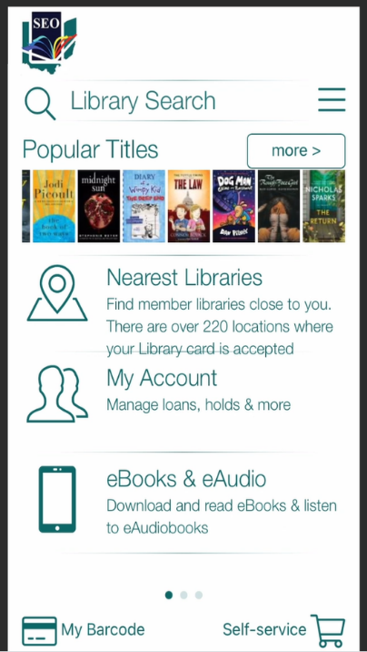

* Tap > **Check-out**
* Get ready to scan the library book’s barcode
* If the patron is NOT within proximity to the library, this button will NOT display
* Find an item you would like to check out
* Open the SEO Libraries Mobile application
* Find the **Self-Service** tab within the application
* Tap > **Self-Service**

1

2

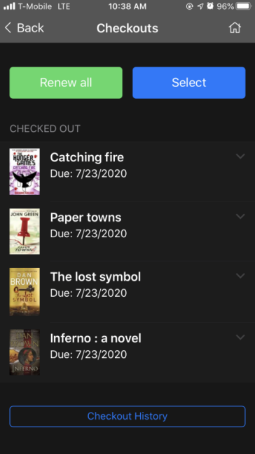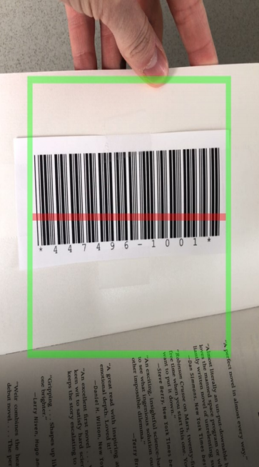

* The SEO Libraries App will confirm the item was successful checked out by appearing on the **Checkouts** page
* The SEO Libraries App will confirm the item was successful checked out by appearing on the **Checkouts** page

4

3